To Professor Laura Wilson
From Mike Schlott
Subject Entertainment Website Analysis
Date February 28, 2021

Persona
For this assignment I will take the persona of Jimi Jenson. Jimi is a passionate twenty-two-year-old who runs a YouTube music review channel. Jimi is looking for a website that will further his passion of music and decided to analyze Genius to see if he can use the website to boost the content on his website.
Introduction
As I reviewed Genius for a potential tool for my YouTube channel, I thought the website to be good not great. As I reviewed the website, I review three big categories. These categories are content, design, and usability. For the content section I reviewed seven categories including such groupings such as relevancy, accuracy, credibility, style, conciseness, purpose, and use of SEO principles. For this section, relevancy and purpose were the strongest categories, with credibility and SEO principles being the weakest. The next section I reviewed was design. I reviewed Genius’ use of visuals, aesthetics, contrast, repetition, alignment, and proximity. In this grouping visuals were lacking but were redeemed by usage of repetition and proximity. The final section I reviewed was the websites overall usability. I scoured the website for examples of functionality, navigation, accessibility, load times, and overall website security. This was a very strong category. The importance of critically reviewing the website is to improve the credibility of my YouTube channel.
Content
When I reviewed the content on Genius’ website, I found all the content to be relevant to the topic of music and musical artists. Nothing really strayed away from the concepts of the website. I found most of the substance of the website to be accurate with a couple issues explaining the lyrics. The issues were not incorrectly stated but just seemed weird to leave out details. I awarded the website half points for credibility because anyone can write the lyric explanations, but still need to get approved by Genius. They made no mention of who approves these credits and how the process works on fixing incorrect lyrics. The website overall had a clear sense of grammar and style and was written to be as concise as possible. Genius has a clear purpose and audience as well by being basically the Wikipedia of music lyrics. One thing I found interesting was after running and SEO test, it kept coming up as a 403 error. I tested it on multiple sites and none of the SEO tests works. You can see this in figure one. All in all, the content was sufficient for Genius. I scored the content portion a 78/100 (fair).

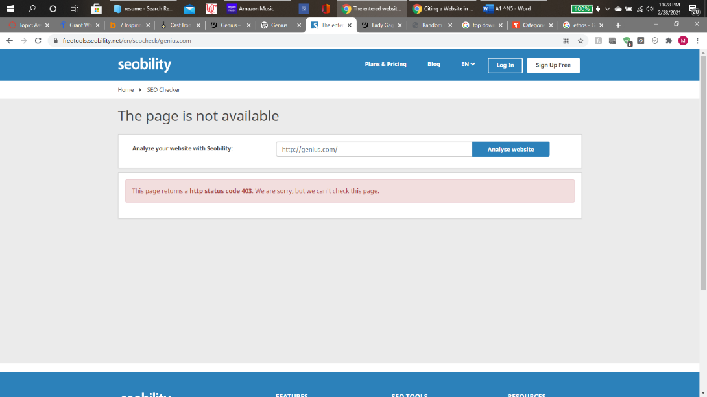
Figure One: depicts the failed SEO test¹
Design
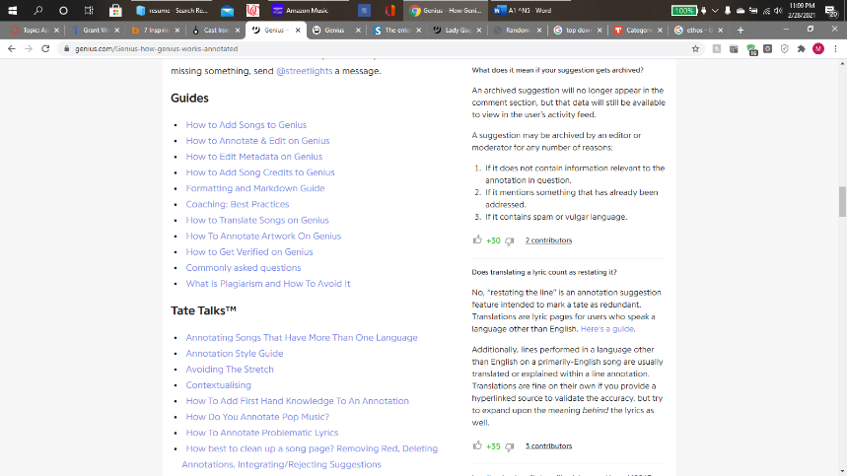
For the design section of my review, I thought the website needs improvement. The website lacked many relevant visuals. This makes the website worse of a resource for content in my YouTube videos. Most of the images were just the album covers for the presented songs and articles and lack the ability to add depth to the website. For the website’s aesthetic, I was also not impressed. Behind the typical yellow this website boasts, the colors were all blacks, white, grays, and obnoxious blue hyperlinks. This is especially annoying the further you get down an article and when the rising sun yellow leaves the page and you are left with an ugly document. Because of this, the contrast received a lower score. On the home page and the beginning of the articles it is nice looking and then dissipates more the further you go down. Genius’ website does a good job with its use of repetition and proximity but falls a little short on its use of proximity and the spacing on some of the articles look sloppy. This is not something I would want to display in a YouTube video. I scored the design section a 69/100 (needs improvement).

Figure 2: depicts the poor aesthetic that occurs towards the bottom of the articles.²
Usability
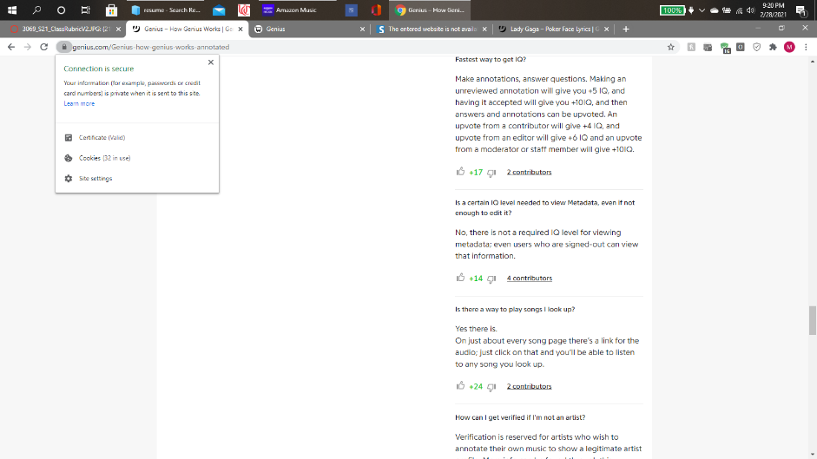
There really is not much to go into on the website’s usability. The website was extremely functional and even seemed to work better on their mobile site. The navigation was easy to learn and was not overdone. The website was very accessible and included very easy to read fonts and headers. I had no issues with load times, and it seemed to be a breeze to move around the website. Google listed the website as secure, so really Genius checked all the boxes. I scored usability 100/100 (excellent).

Figure 3: depicts the websites good security²
Conclusion
After reviewing Genius’ website to see if it would be a valuable tool for my YouTube channel, I have concluded that it is a tool I can use. That being said it has its flaws. In the content section, the website lacked credibility. This makes it difficult to trust things you read on this website. This website also lacked any SEO principles but being a giant in the industry that they are, they really should not have issues bringing traffic to their site. The content scored well to perfect on the rest of the categories netting it a 78/100 score. When reviewing the design of Genius, visuals and aesthetics tanked the site’s scores. Lack of visuals was the main reason. Adding more visuals can go a long way and does not take much effort. They could also run through their website and clean it up by removing the copious amounts of blue hyperlinks and the website would have scored much higher. The CRAP (contrast, repetition, alignment, and proximity) of the website scored well. Some issues with alignment and contrasting colors can really clean up this website. This led to a score of 69/100 for design. The usability on the site had no downfall. All categories score a perfect score and yield the website a 100/100 for usability. Overall, the website can be used as a tool for learning lyrics’ meanings and for some light reading on the music world. I scored the overall website a 247/300 (good).
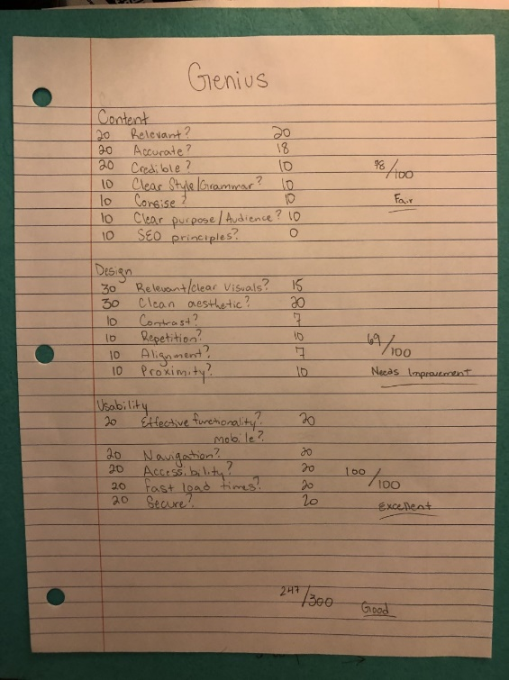
Figure 4: depicts the rubric used to review this site.
References
- “SEO Checker.” Seobility. Accessed February 28, 2021. https://freetools.seobility.net/en/seocheck/genius.com.
- “Song Lyrics & Knowledge.” Genius. Accessed February 28, 2021. https://genius.com/.

